#
# 20200619
# For my account for FreeIPA password was expired. I set it to my current linux password. Bitch!
#
s_s.belogrud@ds-term-ext-net01:~$ sudo -i
[sudo] password for s_s.belogrud:
Password expired. Change your password now.
sudo: Account or password is expired, reset your password and try again
Current Password:
New password:
Retype new password:
root@ds-term-ext-net01:~# passwd s_s.belogrud
Password reset by root is not supported.
passwd: Authentication token manipulation error
passwd: password unchanged
root@ds-term-ext-net01:~#

#
# I’ve got troubles after password expiration and after I’ve changed it to new.
# I couldn’t install FreeIPA client on two new servers.
# This is because to install the client was used my old password. And I had no credentials to permit operations from playbook.
#

# Error looked like this.
# There are no addition info and details.
[support@centos freeipa-client]$ ansible-playbook 20191216-1721.install.freeipa-client.yml -i list_of_hosts --become --extra-vars "ansible_user=bsv ansible_password=$(pass common/linux) ansible_sudo_pass=$(pass common/linux) ansible_ssh_common_args='-oStrictHostKeyChecking=no -oPubkeyAuthentication=no'"
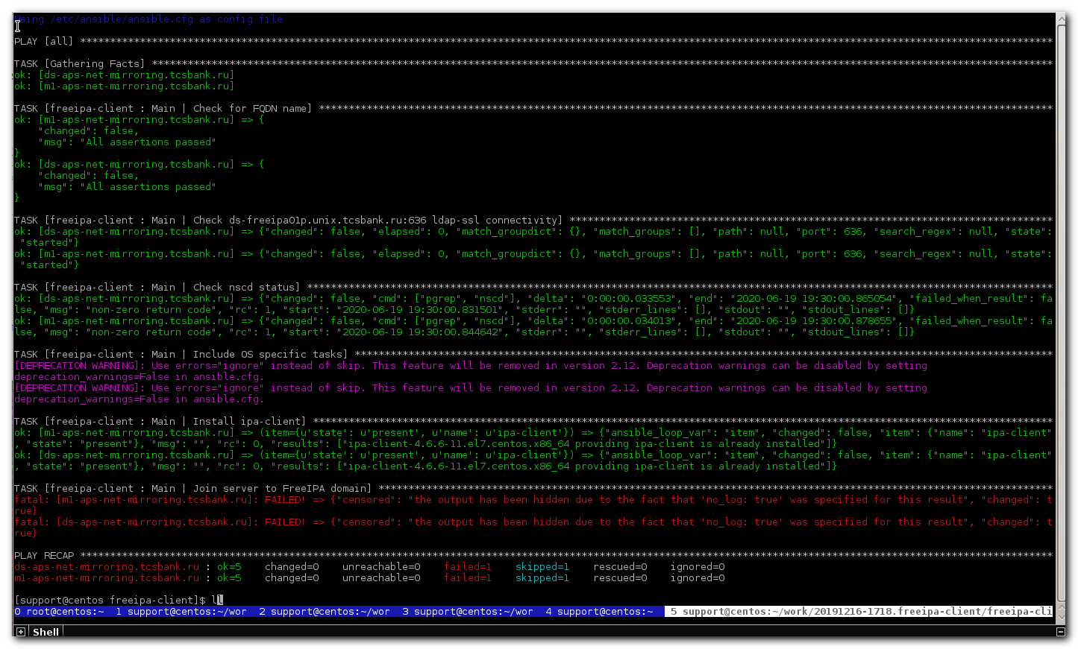

# I’ve commented follow line to turn on more detail log messages.
[support@centos freeipa-client]$ vim roles/freeipa-client/tasks/main.yml
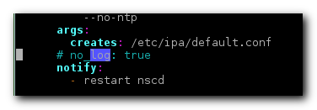

[support@centos freeipa-client]$ ansible-playbook 20191216-1721.install.freeipa-client.yml -i list_of_hosts --become --extra-vars "ansible_user=bsv ansible_password=$(pass common/linux) ansible_sudo_pass=$(pass common/linux) ansible_ssh_common_args='-oStrictHostKeyChecking=no -oPubkeyAuthentication=no'" -v
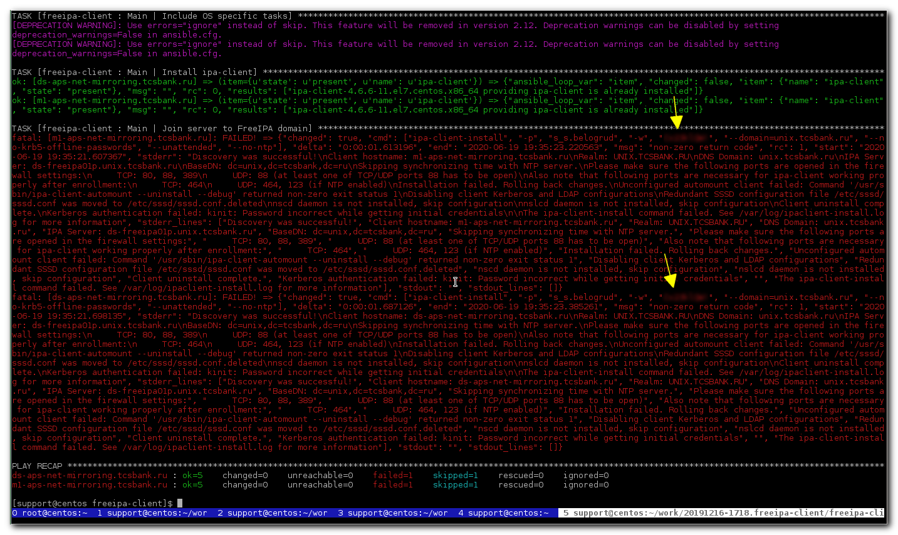

# On FreeIPA portal I couldn’t set my old password. That bitch didn’t allow me to do that.
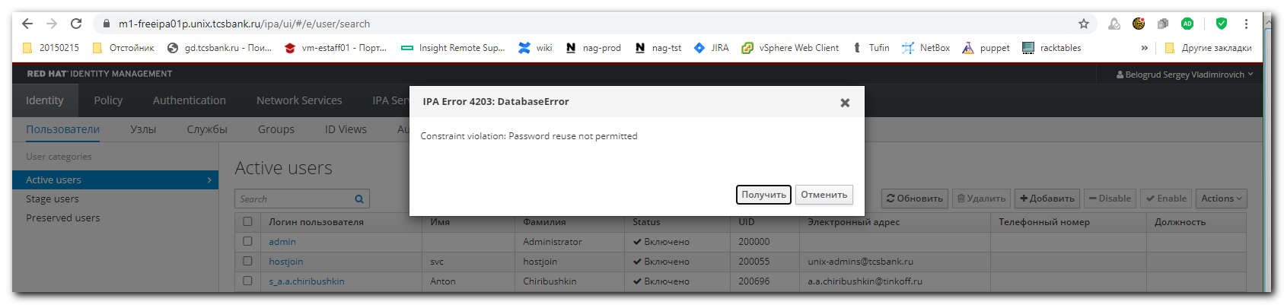

#
# In KeePass I’ve generated new password for my FreeIPA account.
# And wrote new password here.
[support@centos freeipa-client]$ vim roles/freeipa-client/vars/main.yml

# I’ve turned off log - as it was before. To avoid usless spam.
# After that - this playbook became working.
# I’ve installed freeipa client on target hosts.

#
# 20200114
# If everything is OK.
#
[s.belogrud@TCS4357]# ssh s_s.belogrud@ds-devops-prod-consul-3
Creating directory '/home/idm/s_s.belogrud'.
Welcome to Ubuntu 18.04.2 LTS (GNU/Linux 4.15.0-54-generic x86_64)
...

s_s.belogrud@ds-devops-prod-consul-3:~$ sudo -i
[sudo] password for s_s.belogrud:
Your password will expire in 5 day(s).
root@ds-devops-prod-consul-3:~#

#
# 20200114
# If something - wrong.
# Pasha said, that it’s because sometime playbook, that run from AWX, doesn’t create a folder /etc/krb5.conf.d/.
# This folder is empty, but even so it influence on result.
#
[s.belogrud@TCS4357]# ssh s_s.belogrud@ds-devops-prod-consul-3
Warning: Permanently added 'ds-devops-prod-consul-3' (RSA) to the list of known hosts.
Authentication failed.
[s.belogrud@TCS4357]#

#
# I freeipa password into the “pass” utility.
#
[support@centos stash.tcsbank.ru]$ pass insert common/linux-freeipa
Enter password for common/linux-freeipa:
Retype password for common/linux-freeipa:
[support@centos stash.tcsbank.ru]$ pass
Password Store
└── common
├── linux-bsv
├── linux-default
├── linux-freeipa
├── linux
├── linux-other1
├── linux-other2
├── linux-other3
├── linux-other4
└── windows-current
[support@centos stash.tcsbank.ru]$

#
# One trouble was found.
# I’ve changed password and in new password was generated a symbol of one quotation “ ‘ “.
# And my commnad stop working because it started broke command line syntax - additional “ ‘ “.
# And I tried to change my freeipa password again.

#
# For bsv this commnad works well.
#
[support@centos ~]$ for var1_hosts in ds-splunk-nidx01 ; do SSHPASS="$(pass common/linux)" sshpass -e timeout 60 ssh -t -oStrictHostKeyChecking=no -oPubkeyAuthentication=no -oUserKnownHostsFile=/dev/null bsv@${var1_hosts}.tcsbank.ru "( echo '$(pass common/linux)' | sudo -S -i sh -c 'echo;echo;echo ; hostname ; ')" ; done | tee -a /tmp/$(date +%Y%m%d-%H%M).ssh.log.txt
Warning: Permanently added 'ds-splunk-nidx01.tcsbank.ru,10.216.42.73' (ECDSA) to the list of known hosts.
[sudo] password for bsv:

ds-splunk-nidx01.tcsbank.ru
Connection to ds-splunk-nidx01.tcsbank.ru closed.
[support@centos ~]$

# But for freeipa troubled password (with “ ‘ “ symbol)
#
[support@centos ~]$ for var1_hosts in ds-splunk-nidx01 ; do SSHPASS="$(pass common/linux-freeipa)" sshpass -e timeout 60 ssh -t -oStrictHostKeyChecking=no -oPubkeyAuthentication=no -oUserKnownHostsFile=/dev/null s_s.belogrud@${var1_hosts}.tcsbank.ru "( echo '$(pass common/linux-freeipa)' | sudo -S -i sh -c 'echo;echo;echo ; hostname ; ')" ; done | tee -a /tmp/$(date +%Y%m%d-%H%M).ssh.log.txt
Warning: Permanently added 'ds-splunk-nidx01.tcsbank.ru,10.216.42.73' (ECDSA) to the list of known hosts.
Connection to ds-splunk-nidx01.tcsbank.ru closed.
bash: -c: line 0: unexpected EOF while looking for matching `''
bash: -c: line 1: syntax error: unexpected end of file
[support@centos ~]$

#
# And if I tried to change my password via command line and get same trouble as I have gotten with GUI.
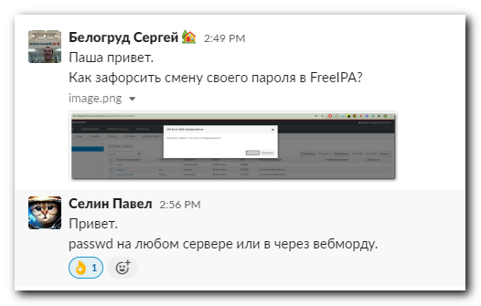

s_s.belogrud@ds-splunk-nidx01:~$ passwd
Current Password:
New password:
BAD PASSWORD: The password is just rotated old one
New password:
Retype new password:
passwd: password updated successfully
s_s.belogrud@ds-splunk-nidx01:~$ passwd
Current Password:
New password:
Retype new password:
Password change failed. Server message: Current password's minimum life has not expired

Password not changed.
passwd: Authentication token manipulation error
passwd: password unchanged
s_s.belogrud@ds-splunk-nidx01:~$

